25.1.1 Editors - Properties Editor - Tools Tab - Edit Mode
Tools Tab in Edit Mode 2
Edit Mode - Mesh Object 2
Normal Tools panel 2
Options panel 2
X Mirror 2
Topology Mirror 2
Live Unwrap 2
Auto Merge Editing 2
Double Threshold 2
Edge Select Mode 2
Edit Mode - Bezier Curve 3
Curve Stroke Panel type Bezier 3
Type 3
Bezier Options 3
Tolerance 3
Method 3
Detect Corners 3
Corner Angle 3
Pressure Radius 3
Taper Radius 3
Projection depth 3
Cursor 3
Surface 3
Offset 3
Absolute Offset 4
Only First 4
Curve Stroke Panel type Poly 4
Type 4
Pressure Radius 4
Taper Radius 4
Projection depth 4
Cursor 4
Surface 4
Offset 4
Absolute Offset 4
Only First 4
Edit Mode - Armature Options panel 5
X Axis Mirror 5
Workflow 5

Tools Tab in Edit Mode

Many object types can be edited in edit mode. Mesh objects, armature, text object and so on. In this chapter we will go through all the object types in edit mode. But just four object types have really relevant settings in the tools tab in edit mode. Mesh Objects. All kind of curve objects. And the Armature.

For the rest of the editable object types the tools tab stays blank.

Edit Mode - Mesh Object

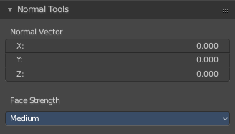
Normal Tools panel
Here you can find some normal related settings.
Not documented. Not to find out how to use. Waiting for the Blender documentation here ...

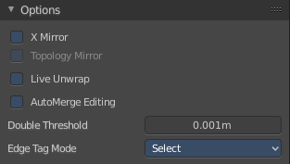
Options panel
Here you can find some mesh specific settings.

X Mirror
X Axis Mirror Editing.

Topology Mirror
Use Topology based mirroring.

Live Unwrap
Changing edges seam recalculates UV Unwrap.

Auto Merge Editing
Automatically merge vertices that are close to each other.

Double Threshold
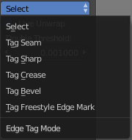
Limit for removing duplicates and 'Auto Merge'.

Edge Select Mode
Edge Select Mode is a drop-down box where you can choose the select method for edges.

Edit Mode - Bezier Curve

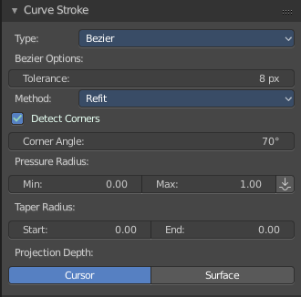
Curve Stroke Panel type Bezier

Type
Here you switch between the curve type Bezier and Poly.

Bezier Options

Tolerance
Allow deviation for a smoother but less precise line

Method
The curve fitting method. Here you can choose between Refit and Split.

Detect Corners
Detect corners and use non aligned angles.

Corner Angle
Corners above this angle are considered as corners.

Pressure Radius
Pressure radius is interesting when you use a tablet. Here you can adjust the Minimum and Maximum pressure radius. When you don't use a tablet then the maximum pressure value will be used.

Taper Radius
Taper factor for the radius of each point along the curve.

Projection depth
Here you can set the method of projection depth.

Cursor
Sets the projection depth to 3D Cursor.

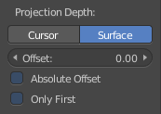
Surface
Sets the projection depth to Surface. Then the curve paints at a surface that is placed under the stroke. It also reveals some more settings for Projection Depth method Surface

Offset
Offset the stroke from the surface.

Absolute Offset
Apply a fixed offset.

Only First
Use the start of the stroke for depth.

Curve Stroke Panel type Poly

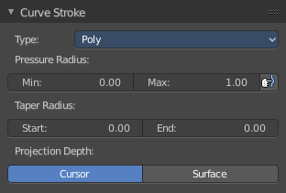
Type
Here you switch between the curve type Bezier and Poly.

Pressure Radius
Pressure radius is interesting when you use a tablet. Here you can adjust the Minimum and Maximum pressure radius. When you don't use a tablet then the maximum pressure value will be used.

Taper Radius
Taper factor for the radius of each point along the curve.

Projection depth
Here you can set the method of projection depth.

Cursor
Sets the projection depth to 3D Cursor.

Surface
Sets the projection depth to Surface. Then the curve paints at a surface that is placed under the stroke. It also reveals some more settings for Projection Depth method Surface

Offset
Offset the stroke from the surface

Absolute Offset
Apply a fixed offset

Only First
Use the start of the stroke for depth.

Edit Mode - Armature Options panel
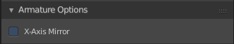

X Axis Mirror
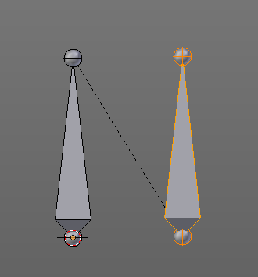
X Axis Mirror is made to sync the right side of a symmetrical armature with the left side of a symmetrical armature. Means you can create just one half of a skeleton. And then simply mirror it over to the other half. And any further changes that you do at the one side will also apply to the other side of the armature. This includes the whole FK IK setup. And can save you lots of work therefore.
To get X Axis mirror to work requires a bit preparation work.

Workflow
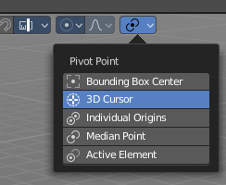
Create a armature, with some bones at the one side. Like this. The 3D cursor needs to be at 0/0/0. The left bone is in the middle. Think of it as the backbone. The right bone has an offset, and shall represent our right side of the armature.
Change the Pivot Point in the Header to 3D Cursor. Important step. We want to mirror around the 3D Cursor.
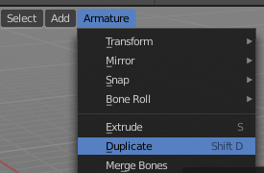
Now select the right side of the armature. Border select is one fast way. But NOT the bone in the middle, which is our backbone. We don't want to mirror this one too.

Duplicate what we have selected. And click immediately to leave the duplicate mode. Or you will pull the duplicated part around. Which is not what we want.

Next we will scale our new created armature part by -1 to mirror it over to the other side. Activate Scale, don't move the mouse, but type immediately in X for the axis and -1 for the scale factor.

This will create our mirrored armature part.

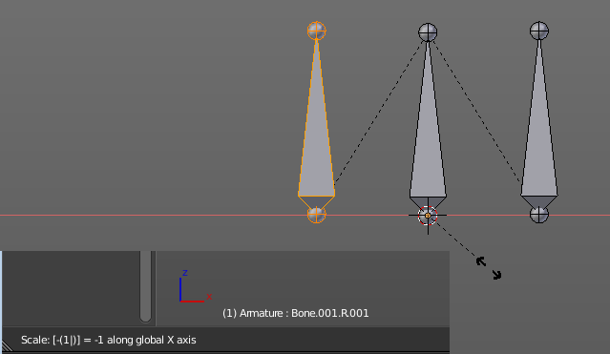

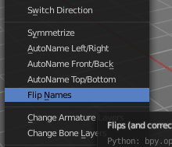

Next important step is to Flip Names. This renames the mirrored bones. Bone.001.R becomes without this step Bone.001.R.001. With rename we get Bone.001.L

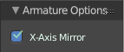
And now we are finally arrived at X Axis Mirror. Tick it.

Now you should be able to modify the one side of the armature, and the other side will be modified too. This includes as told above also FK IK set-ups that you do in Pose mode.

